**Support:** [**mm_fin@mit.edu**](mailto:mm_fin@mit.edu)

Forward Contracts

Basic pricing formula: $F_{0}=S_{0}e^{rT}=\frac{S_{0}}{D_{T}}$, where $D_{T}$ is the discount factor

Dividend-paying stock: $F_{0}=\left(S_{0}-PV\left(D\right)\right)e^{rT}$ or $F_{0}=S_{0}e^{\left(r-q\right)T}$

Coupon-paying bond: $F_{0}=\left(B_{0}-PV\left(C\right)\right)e^{rT}$

Foreign currency: $F_{0}=S_{0}e^{(r_{d}-r_{f})T}$

Commodities: $F_{0}=\left(S_{0}+PV\left(U\right)-PV\left(Y\right)\right)e^{rT}$ or $F_{0}=S_{0}e^{\left(r+u-y\right)T}$

General rule for the forward price: any inflows associated with the underlying are deducted, outflows are added.

Value of a long forward contract at time $t$ ­: $\left(F_{t}-K\right)e^{-r\left(T-t\right)}$, where K is the contractual delivery price (normally $K=F_{0}$).

Hedge ratio: $\frac{N_{S}}{N_{F}}=\frac{E\left[dF\right]}{E\left[dS\right]}$. Rationale: have the same expected price change, $N_{S} E\left[dS\right]=N_{F} E[dF]$.

Note about wording: “exchange currency 1 for currency 2” means “sell currency 1 for currency 2”.

Futures and Swaps

Margin account: a trader must maintain at least the maintenance margin; entitled to withdraw funds in excess of initial margin.

Swap parties: fixed rate payer is said to be long the swap (so we can think of floating rate as “underlying asset”).

Fixed-float swap equation, assuming $n$ coupon periods per year: $\frac{c}{n}⋅F{⋅D}_{\frac{1}{n}}+\frac{c}{n}⋅F{⋅D}_{\frac{2}{n}}+…+\left(1+\frac{c}{n}\right)⋅F{⋅D}_{T}=F$. Par fixed rate: $c=\frac{n⋅(1-D_{T})}{D_{\frac{1}{n}}+D_{\frac{2}{n}}+…+D_{T}}$. $D_{t}$ is the discount factor for time $t$.

Underlying asset in an Eurodollar futures is a 3M deposit. Futures maturity is underlying deposit start date. To hedge future borrowing interest rate – short the futures.

Effective rate on an interest rate futures: $\frac{100-QuotedPrice}{100}$. Long 1 futures is equivalent to locking a lending rate on $1M principal.

Currency swap rate (as presented in the lecture, i.e. fixed-fixed with no principal exchange): $K=S_{0}\frac{D_{1}^{f}+D_{2}^{f}+…+D_{N}^{f}}{D_{1}^{d}+D_{2}^{d}+…+D_{N}^{d}}$, where $D_{i}^{d}$ and $D_{i}^{f}$ are discount factors in domestic and foreign currencies on $i$-th exchange date. Note: $K$ is a currency exchange rate, not an interest rate!

Commodity swap rate: $K=\frac{F_{1}D_{1}+F_{2}D_{2}+…+F_{N}D_{N}}{D_{1}+D_{2}+…D_{N}}$, where $F_{i}$ and $D_{i}$ are the forward commodity price and discount factor on $i$-th exchange date. Assuming $F_{i}=\frac{S_{0}}{D_{i}}$, $K=S_{0}\frac{N}{D_{1}+D_{2}+…D_{N}}$

Total Rate of Return Swap is exchange of $TotalReturn=CashFlows+ChangeInMarketValue$ on a reference asset vs. $InterestRateIndex + Spread$. Receiver TROR swap is equivalent to long asset, short FRN.

Duration and Convexity

Macaulay duration: $D=\frac{t_{1}PVCF_{1}+t_{2}PVCF_{2}+…+t_{N}PVCF_{N}}{PVTCF}$

Modified duration: $D_{M}=\frac{D}{1+\frac{y}{k}}$, where $y$ is YTM, $k$ is coupon frequency

$\frac{dP_{B}}{P_{B}}=-D_{M}dy$, or $dP_{B}=-P_{B}D_{M}dy$, where $P_{B}$ is the bond price

Dollar duration: $D_{d}=D_{M}P_{B}=-\frac{dP_{B}}{dy}$; $dP_{B}=-D_{d}dy$

Convexity: $C=Σ_{t=1}^{T}\frac{t\left(t+1\right){CF}_{t}}{{\left(1+\frac{y}{k}\right)}^{t+2}k^{2}}/P_{B}$, where T is number of periods (maturity times $k$)

Dollar convexity: $C_{d}=C⋅P_{B}$

Approximation of the price change: $\frac{ΔP_{B}}{P_{B}}≈-D_{M}Δy+\frac{1}{2}C{\left(Δy\right)}^{2}$

The modified duration of a bond portfolio is the value-weighted average modified duration of bonds in the portfolio. The dollar duration of a portfolio is the sum of the dollar durations of the bonds in the portfolio. Same for convexity.

For the forward contract: $dF≈-FD_{F}dy$, where $F$ is the prepaid (PV) forward price of the security in the forward contract, $D_{F}$ is the modified duration of the future contract. Hedging with a forward: $P_{B}D_{M}=FD_{F}$

Dollar duration of a fixed rate receiver swap: $P_{B}^{fixed}D_{M}^{fixed}-P_{B}^{float}D_{Effective}^{float}$

Hedge ratio is the same as dollar duration.

Numerical duration with central differencing: $D_{eff}=\frac{1}{P_{initial}}⋅\frac{P_{rise}-P_{fall}}{2⋅Δy}$

Numerical convexity: with central differencing: $C_{eff}=\frac{1}{P_{initial}}⋅\frac{P_{rise}+P_{fall}-2P_{initial}}{{\left(Δy\right)}^{2}}$

Option Strategies

Put-call parity: $C-P=(F-K)e^{-rT}$; for a non-dividend paying stock: $C-P=S-Ke^{-rT}$; for futures options: $C-P=F-K$

Protective put: long stock, long put

Covered call: long stock, short call

Bear spread: short OTM put ($K_{1}$), long ITM put ($K_{2}$), where $K_{2}>K_{1}$

Bull spread: long ITM call ($K_{1}$), short ITM call ($K_{2}$), where $K_{2}>K_{1}$

Butterfly spread: long 1 call ($K_{0}$), short 2 calls ($K_{1}$), long 1 call ($K_{2}$), where $K_{0}<K_{1}<K_{2}$, and $K_{1}=\frac{K_{0}+K_{2}}{2}$

Straddle: long put, long call the same strike

Strangle: long put ($K_{0}$), long call ($K_{1}$), where $K_{1}>K_{0}$

American call option on a non dividend paying stock is never optimal to exercise early.

Pricing Options

Careful with binomial model for dividend-paying stock: the tree is not recombining!

**Replicating portfolio approach (1 step)**

* Find delta: $Δ=\frac{V_{u}-V_{d}}{S_{u}-S_{d}}$
* Find the amount of bond: $B=e^{-rT}(V_{u}-ΔS_{u})$
* Find the option value: $V_{0}=Δ⋅S_{0}+B_{0}$

**Risk neutral approach (1 step)**:

* Find the risk neutral probability: $q^{*}=\frac{S_{0}e^{rT}-S_{d}}{S_{u}-S_{d}}$
* Find the option value: $V_{0}=e^{-rT}E^{*}\left[V_{T}\right]=e^{-rT}(q^{*}V_{u}+\left(1-q^{*}\right)V_{d})$

**Calibrated binomial tree**:

* Assume $S_{t+h}=S_{i}u$ with probability $q$, $S_{t+h}=S_{i}d$ with probability $1-q$, $u=e^{σ\sqrt{h}}$, $d=\frac{1}{u}$. Then find $q^{*}=\frac{e^{rh}-d}{u-d}$
* Find the option value on a given node at time t: $V_{t}=e^{-rh} E^{*}[V_{t+h}]$

For a futures contract: $q^{*}=\frac{1-d}{u-d}$

**BS formula for dividend paying stock**:

Call: $c=Se^{-δ(T-t)}N\left(d_{1}\right)-Ke^{-r\left(T-t\right)}N\left(d_{2}\right)$

Put: $p=Ke^{-r\left(T-t\right)}N\left({-d}_{2}\right)-Se^{-δ(T-t)}N\left({-d}_{1}\right)$

where $d_{1}=\frac{\ln{\frac{S}{K}+\left(r-δ+\frac{1}{2}σ^{2}\right)\left(T-t\right) }}{σ \sqrt{T-t}}$, $d_{2}=d_{1}-σ\sqrt{T-t}=\frac{\ln{\frac{S}{K}+\left(r-δ-\frac{1}{2}σ^{2}\right)\left(T-t\right) }}{σ \sqrt{T-t}}$

$Δ=N\left(d_{1}\right)$ for calls, $-N\left(-d_{1}\right)$ for puts

**Put-call parity: $C-P=Se^{-δ(T-t)}-Ke^{-r(T-t)}$**

**BS formula for currency options**: same as for dividend-paying stock (substitute dividend rate $δ$ with foreign interest rate $r_{f}$)

**Black’s formula for futures options**:

Call: $c=e^{-r(T-t)}[FN\left(d_{1}\right)-KN(d_{2})]$

Put: $p=e^{-r(T-t)}[KN\left({-d}_{2}\right)-FN\left(-d_{1}\right)]$

where $d_{1}=\frac{\ln{\frac{F}{K}+\frac{1}{2}σ^{2}\left(T-t\right) }}{σ \sqrt{T-t}}$, $d_{2}=d_{1}-σ\sqrt{T-t}$

**Greeks**

Mid-point approach for numerical estimation of gamma: $Γ≈\frac{V\left(S_{0}+\frac{ΔS}{2}\right)+V\left(S_{0}-\frac{ΔS}{2}\right)-2V\left(S_{0}\right)}{{\left(\frac{ΔS}{2}\right)}^{2}}$, where $ΔS$ is stock price change, not the delta )

Delta-Gamma Hedging

Suppose we have one option with $Δ$ and $Γ$. We can hedge it with portfolio of $N^{S}$ shares of stock and $N^{*}$ options with different expiration, with $Δ^{*}$ and $Γ^{*}$. To delta and gamma hedge, solve the system of equations for $N$ and $N^{*}$:

$1⋅Δ+N^{S}⋅1+N^{*}⋅Δ^{*}=0$; $1⋅Γ+N^{*}⋅Γ^{*}=0$

Solution: $N^{*}=-\frac{Γ}{Γ^{*}}$, $N^{S}=-Δ+N^{*}⋅Δ^{*}$

Volatility

For low $K/S$, BS formula underprices puts and calls. For high $K/S$– overprices

Common vol models: deterministic – constant elasticity of variance; stochastic – Heston model; jump diffusion

Exotic options

**Binary options**

Cash-or-nothing call. Payoff: $I\{S_{T}>K\}$. Price: $e^{-r\left(T-t\right)}N(d_{2})$

Cash-or-nothing put. Payoff: $I\{S_{T}<K\}$. Price: $e^{-r\left(T-t\right)}N({-d}_{2})$

Asset-or-nothing call. Payoff: $S_{T}⋅I\{S_{T}>K\}$. Price: $S_{t}e^{-δ\left(T-t\right)}N(d_{1})$

Asset-or-nothing put. Payoff: $S_{T}⋅I\{S_{T}<K\}$. Price: $S_{t}e^{-δ\left(T-t\right)}N(-d_{1})$

Asset-or-nothing call – cash-or-nothing call = vanilla call

**Asian options**

Average price call. Payoff: ${\left(A\left(T\right)-K\right)}^{+}$

Average price put. Payoff: ${\left(K-A\left(T\right)\right)}^{+}$

Average strike call. Payoff: ${\left(S_{T}-A\left(T\right)\right)}^{+}$

Average strike put. Payoff: ${\left(A\left(T\right)-S_{T}\right)}^{+}$

Both arithmetic and geometric averages are possible. Geometric can be priced with Black’s model. All can be priced with binomial trees and MC

**Barrier options**

Down / up, in / out

Parity relations: $c=c_{ui}+c_{uo}$, $c=c_{di}+c_{do}$; same for puts

Rebate options: fixed payoff if underlying price falls below a barrier (down rebate) or rises above a barrier (up rebate)

**Lookback options**

Floating lookback call. Payoff: $S_{T}-S_{min}$

Floating lookback put. Payoff: $S_{min}-S_{T}$

Fixed lookback call. Payoff: ${\left(S_{max}-K \right)}^{+}$

Fixed lookback put. Payoff: ${\left(K-S_{max} \right)}^{+}$

Analytical solutions exist for lookbacks.

**Exchange options**

Exchange call. Payoff: ${\left(S_{T}-N_{T}\right)}^{+}$. Price: $Se^{-δ_{S}⋅T}N\left(d_{1}\right)-Ne^{-δ_{N}⋅T}N\left(d_{2}\right)$, where $d_{1}=\frac{\ln\left(\frac{Se^{-δ_{S}T}}{Ne^{-δ_{N}T}}\right)+\frac{1}{2}σ^{2}T}{σ\sqrt{T}}$, $d_{2}=d_{1}-σ\sqrt{T}$, $σ=\sqrt{σ_{S}^{2}+σ_{N}^{2}-2ρσ_{S}σ_{N}}$

**Compound options**

Calls on calls, calls on puts etc.

**Gap options**

Gap call. Payoff: $\left(S-K_{1}\right)⋅I\{S>K_{2}\}$. Price: $Se^{-δ⋅T}N\left(d_{1}\right)-K_{1}e^{-r⋅T}N\left(d_{2}\right)$, where $d_{1}=\frac{\ln{\frac{S}{K_{2}}+\left(r-δ+\frac{1}{2}σ^{2}\right)T}}{σ T}$, $d_{2}=d_{1}-σ\sqrt{T}$

Hints for Monte Carlo simulation

To simulate stock price under BS model: $S_{t+h}=S_{t}⋅e^{\left(r-\frac{σ^{2}}{2}\right)⋅h+σ\sqrt{h}ϵ_{t}}$, where $ϵ_{t}∼N(0,1)$

To generate correlated Gaussians: $ϵ_{2,t}=ρϵ_{1,t}+\sqrt{1-ρ^{2}} {\hat{ϵ}}_{t}$

Bonds and Interest Rates Options

Black’s model may be used option on forward value of bonds when option expiration << bond maturity.

**Binomial trees**

One way to calibrate binomial tree with short rates: $r_{t+1, H}=r_{t}\left(1+d\right)$, $r_{t+1, L}=r_{t}/\left(1+d\right)$. Setting $d=σ$ for annual time step, and $q=0.5$, we will match the observed volatility.

Another way, more commonly used in the course: $r_{H}=r_{L}e^{2σ}$

To get long rates from short: price a ZC bond using a binomial tree with short rates, and then find the long rate as a bond YTM.

**Bonds with embedded options**

Callable bond = vanilla bond – call option

Puttable bond = vanilla bond + put option

To price a bond with embedded option: use a rate model (e.g., binomial tree) to price a vanilla bond, and the same model to price an option

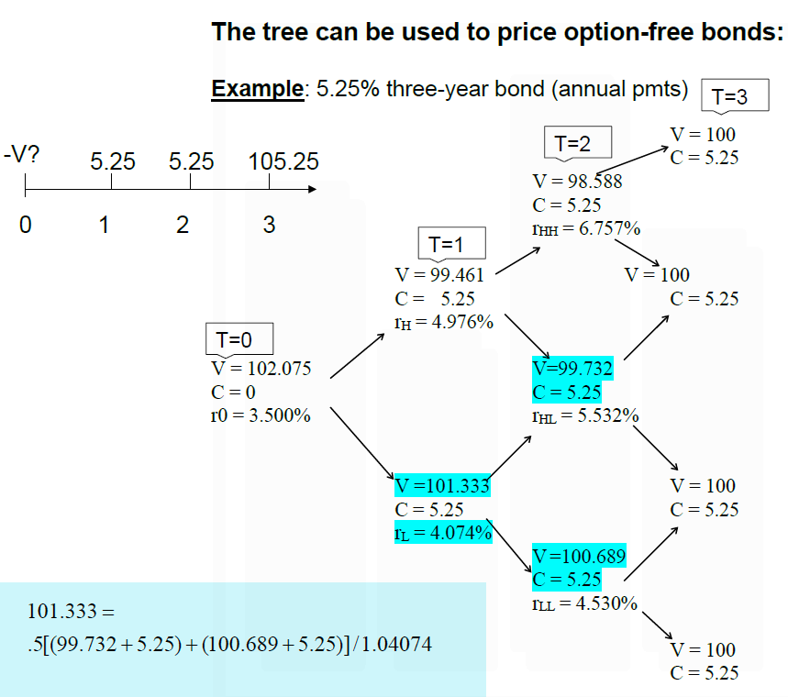

**Interest rate options**

Cap: strip of call options (caplets) on a variable inter**est rate. $Payoff = Principal× Period Length× {\left(R_{T} - K\right)}^{+}$

Credit Risk

**Statistical approach**

Credit spread – difference in YTM on a risky bond and treasury bond. Option-adjusted spread additionally assumes no embedded options

Expected cash flows: weighted on the default probability; for the default scenario – based on the recovery rate. Expected return is the interest rate that discounts the expected cash flows to bond price

YTM, unlike expected return, takes the promised cash flows as certain

**Structural approach**

Equity is call option on firm’s assets. Payoff: $E_{T}={\left(V_{T}-F\right)}^{+}$

Debt is a risk-free bond minus put option on firm’s assets. Payoff: $F-{\left(F-V_{T}\right)}^{+}$

Loan guarantee is a put option on firm’s assets.

**Pricing a loan guarantee with a 1-step binomial tree**

Construct a tree with payoff of a risk-free bond $B_{T}$: same face value on terminal nodes

Construct a tree with firm’s assets value $V_{T}$

Construct a tree with payoff of a guarantor - ${\left(F-V_{T}\right)}^{+}$

Solve the system of equations: $x⋅B_{T}$ + $y⋅V_{T}= -{\left(F-V_{T}\right)}^{+}$ (for every terminal node)

Price of the guarantee: $x⋅B_{0}$ + $y⋅V_{0}$

**The Merton model**

Assumes firm’s assets follow GBM. We observe stock prices and stock vol in the market. Solve 2 equations for $V_{0}$ and $σ$: $E=Call(V_{0},F,r,T,σ)=V_{0} N\left(d_{1}\right)-F e^{-rT}N\left(d_{2}\right)$, where $d_{1}=\frac{\ln{\frac{V_{0}}{F}}+\left(r+\frac{σ^{2}}{2}\right)T}{σ\sqrt{T}}$, $d_{2}=d_{1}-σ\sqrt{T}$; $σ_{E}=\frac{V_{0}N\left(d_{1}\right)}{E}σ$

Find value of the debt: $D_{0}=V_{0}-E_{0}=V_{0}-Call(V_{0},F,r,T,σ)$

Alternatively, by put-call parity: $D_{0}=Fe^{-rT}-Put(V_{0},F,r,T,σ)$, where put can be interpreted as a guarantee

Credit spread: $y-r=-\frac{1}{T}\ln{(1-e^{rT}⋅Put(\frac{V_{0}}{F},1,r,T,σ))}$. Here, $y$ is YTM: $D_{0}=e^{-yT}F$

Pricing senior and junior debt

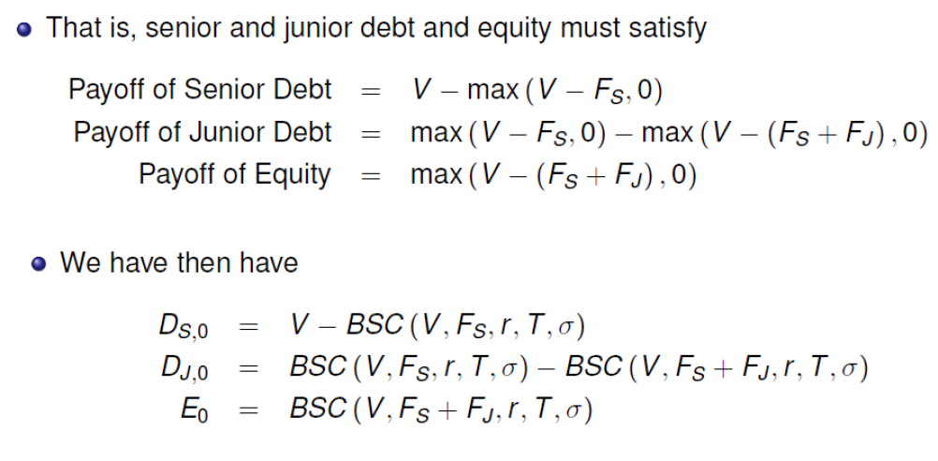

Credit Derivatives

**CDS.** Protection buyer pays periodic premium, % of face value. In the event of default, buyer delivers distressed assets and receives face value in cash (if physical settlement); or the difference between face value and market value of a distressed asset (cash settlement)

Securitization

Investor in an equity tranche: long correlation (benefits). In a senior tranche: short correlation (looses)

Modelling the correlation effect: find payoffs of the securities in default; find risk-neutral PDs; find the probabilities of every possible scenario; find the total payouts for every possible scenario; find the payouts for every tranche and scenario; weight by probability of a scenario; find expected payout of a tranche; discount with a risk-free-rate; find the yield

PSA (Public Securities Assiciation) model assumes flat prepayment rate of 6% p.a. after 30 months

Pass-through securities: CFs distributed pro rata. Sequential pay structure: principal distributed by class priority (class A first, B second etc); interest goes to the most junior class

Interest only (IO): if rates go up, then (1) NPV goes down, so effective duration goes up; (2) prepayment slows down, NPV goes up, so effective duration goes down

Principal only (PO): if rates go up, then (1) NPV goes down, so effective duration goes up; (2) prepayment slows down, NPV goes down, so effective duration goes up